Practical 3: Exploring Router and VLAN security, setting up access lists using Cisco Packet tracer

**Date:-19/08/2023 Submission Date:- 26/08/2023**

**Write-up: -**

* **Access Control List**
* **Types of Access Control List**
* **RBAC**

1. **Configure the router and apply ACL rules as follows:-**

* **192.168.1.2 deny**
* **Permit any**

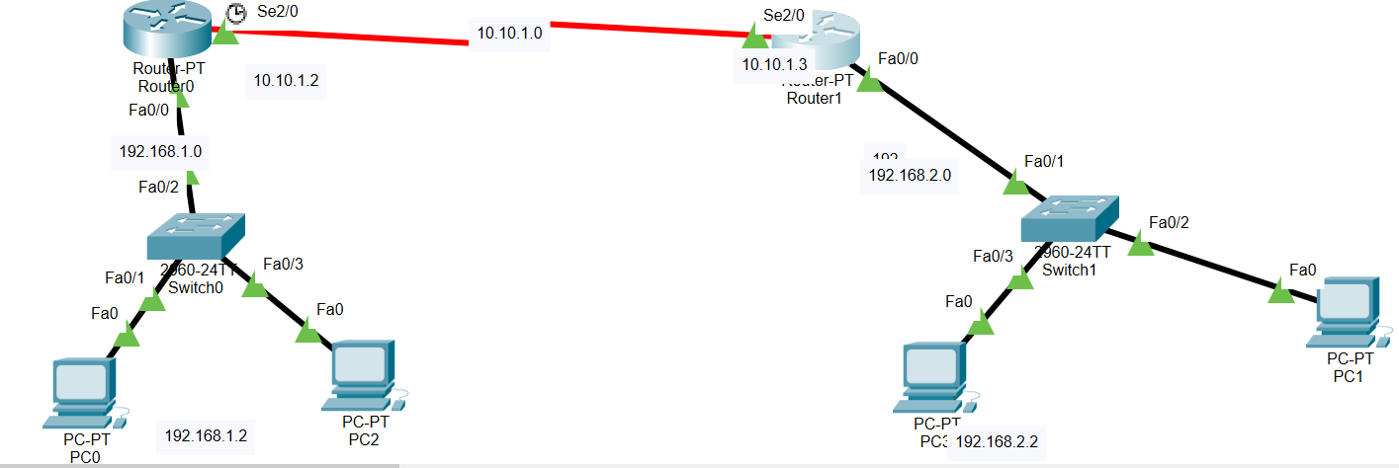

1. **Configure the router and apply ACL rules as follows: -**
2. **Deny the host 192.168.1.1 with the network 192.168.2.0**
3. **Deny the host 192.168.1.2 with the network 192.168.2.0**
4. **Deny the network 192.168.3.0 with the network 192.168.2.0**
5. **Permit all the remaining traffic**

